**Neural Networks:**

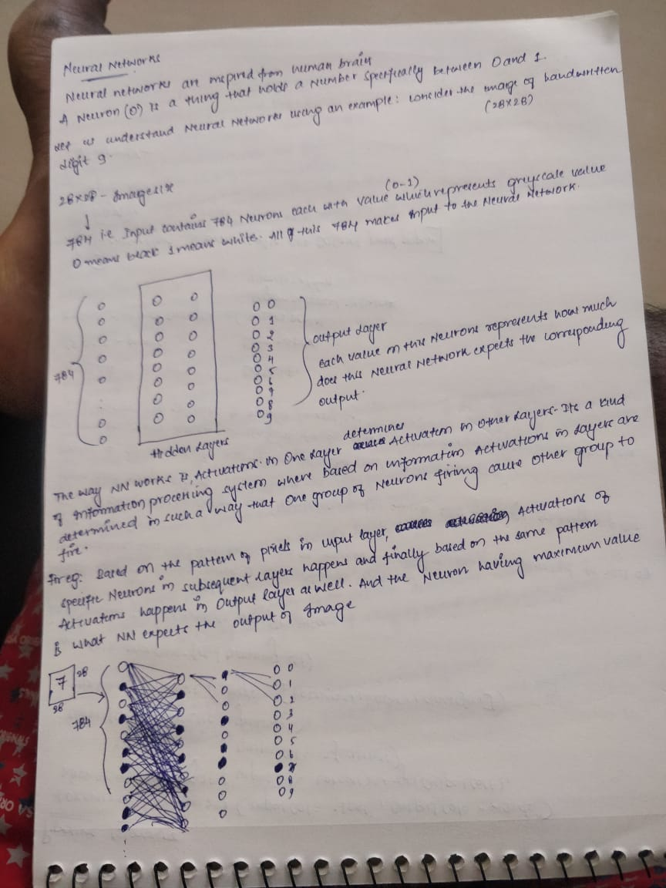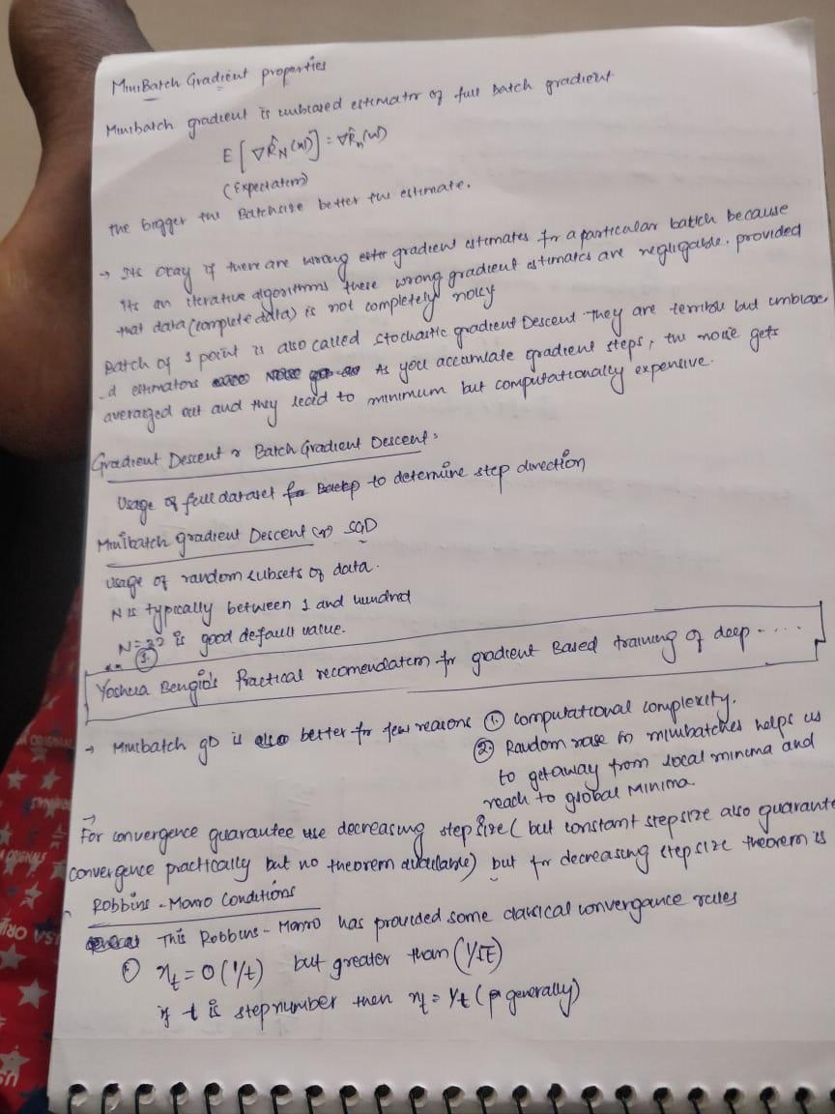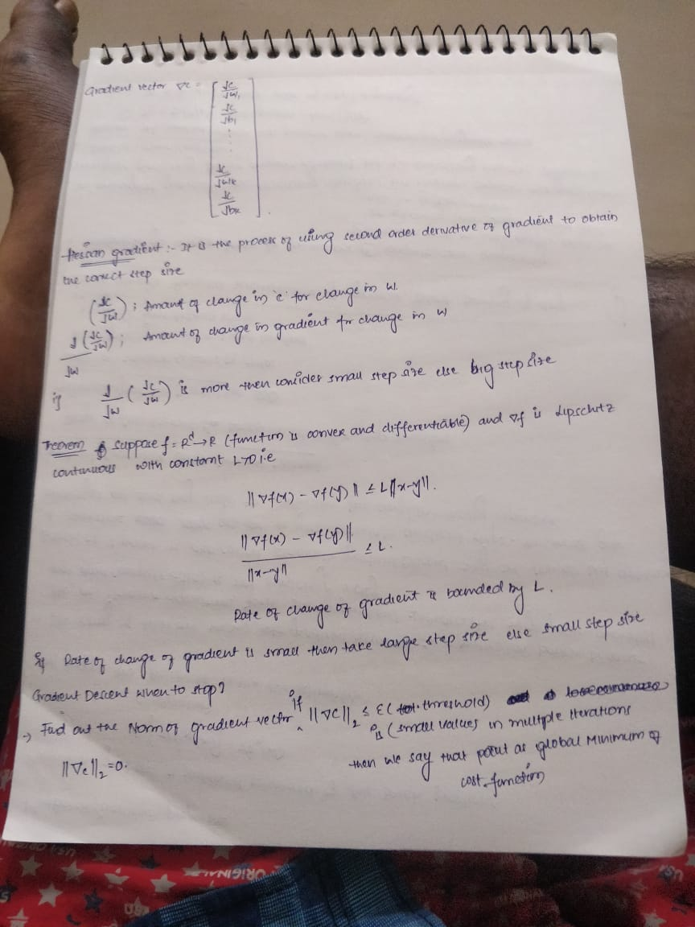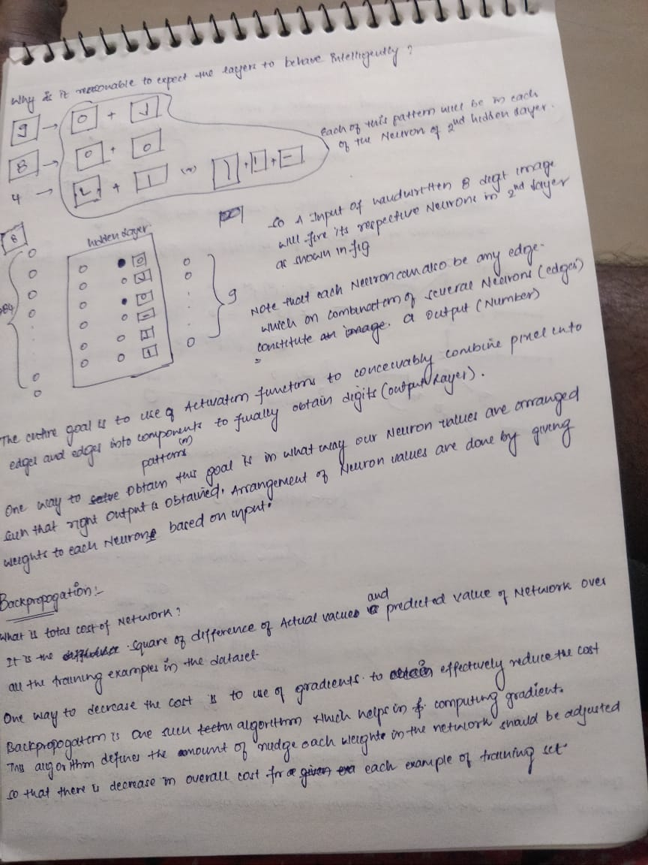

**Multi Layered Perceptron:**

**What is the use of having MLP’s?**

Answer:

1. Biological Inspiration
2. Mathematical Argument:

By using a multi layered structure, we can arrive at complex mathematical functions to solve the problem.

They are very powerful models, but they over fit easily.

**Notation of MLP:**

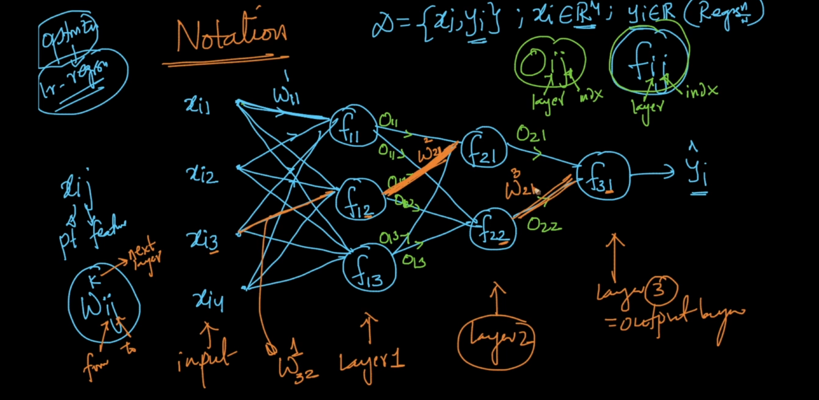

**What is model Training in neural networks?**

Training means finding the best parameter (weights and biases which have minimum loss values) by using the training data.

The process of model training involves finding out the best parameters W and b at which the cost function is minimum.

This process can be called as optimization and there are optimization algorithms like SGD or GD which leverages the concept of gradients to find the best w and b.

**SGD-Stochastic Gradient Descent:**

Step-1: The algorithm starts by randomly initializing the W’s and b’s

Step-2: Using the randomly initialized values all the datapoints(random subset of training data) are feed forwarded through the network and cost is calculated at the end of the network.

Step-3: Gradients are calculated for each weight( The effect of each W value on cost function is cacluated) and by using below formulae the weights in the network are updated

Wnew=Wold –eta*Gradient(dc/dw)

Step-4: Using these new weights the random subset of training data is again feed forwarded over the network and cost calculated in last layer and again the gradient is calculated and weights are updated.

Step-5: This process is repeated iteratively whenever the loss function become very minimal and it no longer changes and settles at one particular value.

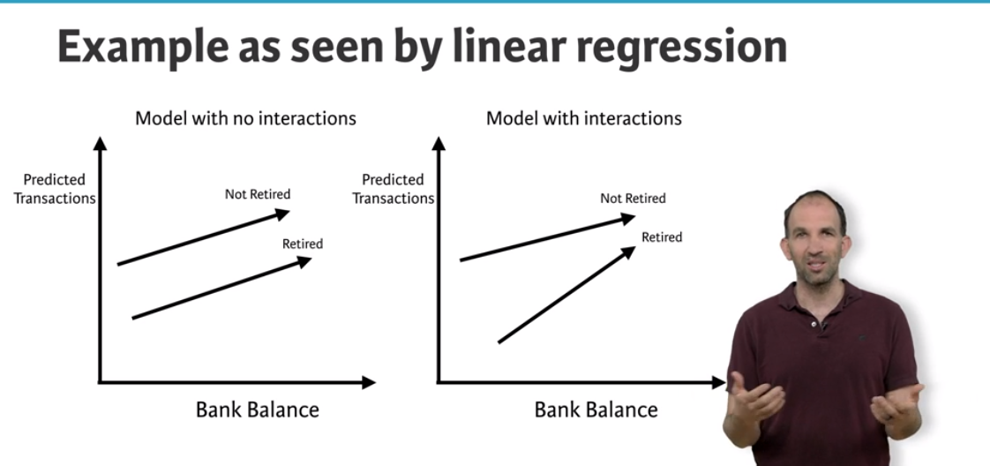

On the left is Linear model without any interactions both the lines are parallel, But in case of neural networks which allows interactions the lines are not parallel.

Neural networks accounts for interactions very well.

Deep learning uses really powerful neural networks.

**Difference of using Neural Networks:**

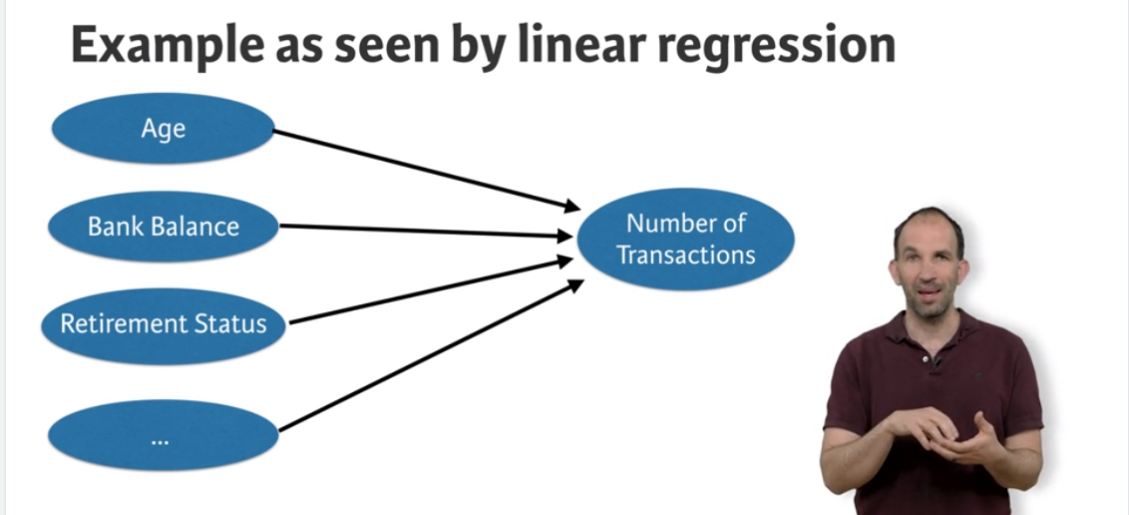

Linear regression predicts number of transactions as sum of individual features and will not consider any interaction between them.

**Whereas Deep learning captures interactions as below:**

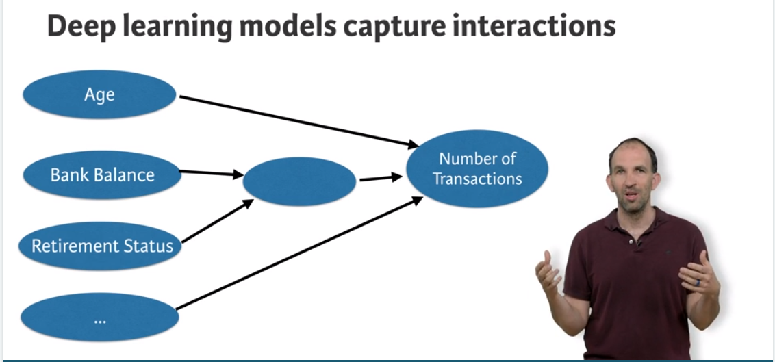

Ideally the below diagram summarises how interactions in Neural networks works.

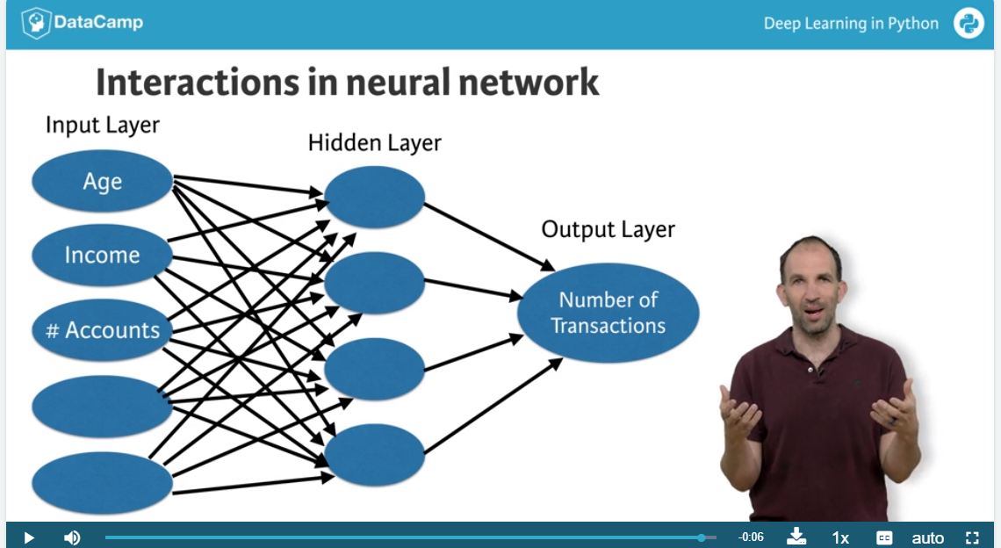

Ideally more the nodes in Hidden layer, more the interactions.

**Forward Propagation:**

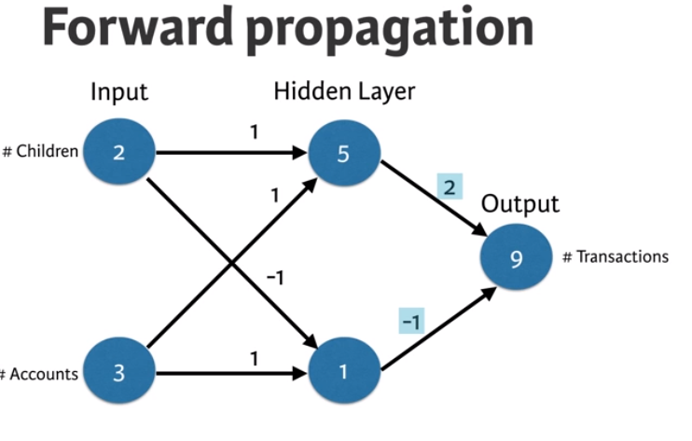

Code for above Forward Propagation:

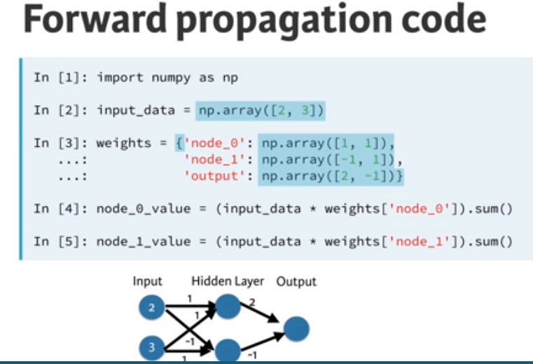

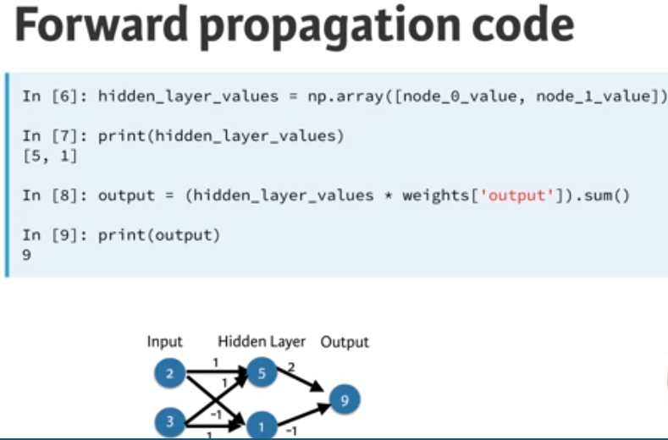

**Activation Functions:**

Activation functions are applied to each node in the Hidden network.

Usage of activation function makes neural networks more powerful by introducing non linearity to the solution.

**Deep Networks:**

Deep networks internally build representations of patterns in the data.

By using Deep Networks , Neural networks partially replace the need of feature engineering.

Subsequent layers in deep networks sophistically build robust representations of raw data.

Good thing about deep learning is the modeller doesn’t need to tell the model of interactions.

Based on the given data the model will automatically find the weights that finds the relevant patters useful for predictions.

**Back Propagation:**

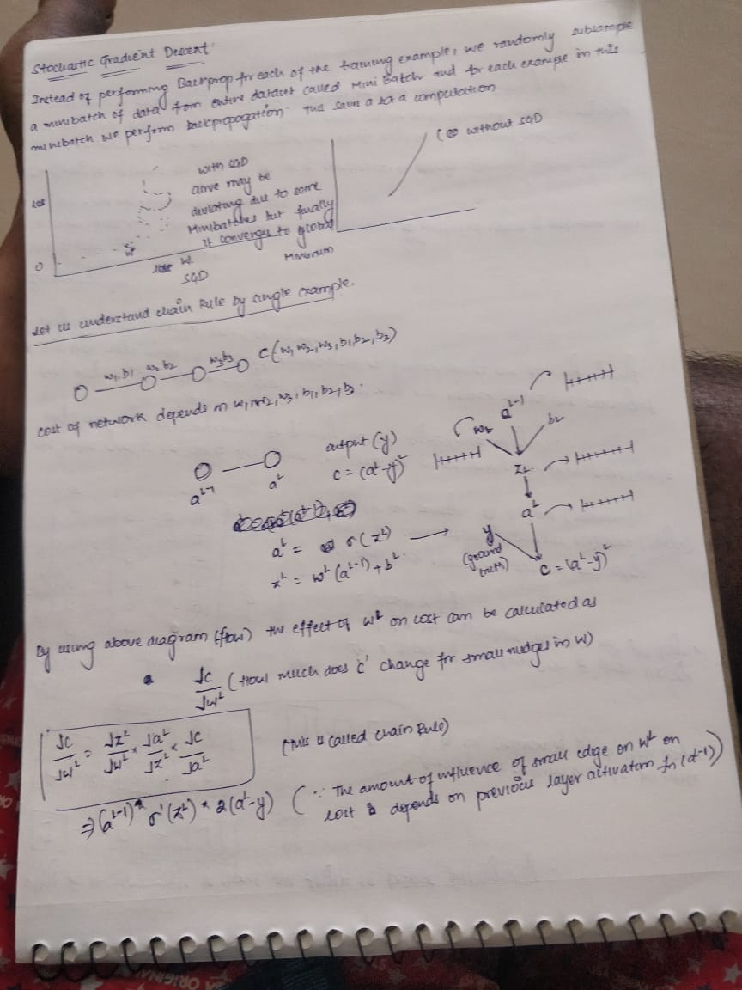

Value of gradient calculated during backprop is obtained using three terms.

1. Derivative of activation function of node for which this weight feeds into (aL node in the above diagram)
2. Activations of the node feeding into the weight (aL-1 node in the above diagram)
3. Derivative of loss function w.r.t the node it feeds into (aL node in our diagram)

Hence to obtain gradient for a weight during back prop these above 3 values are mandatory.

**Code for Gradient calculation (for example in the above image):**

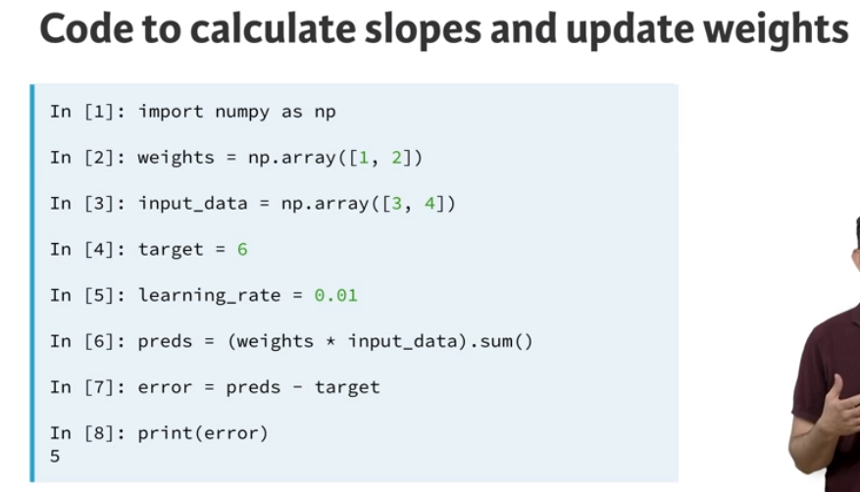

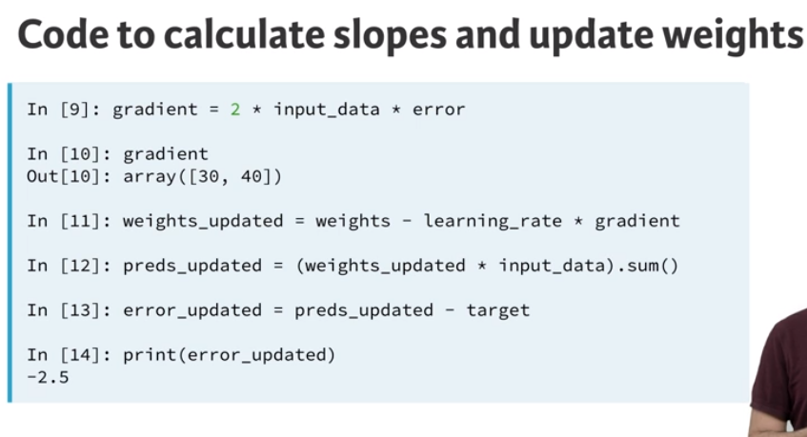

**Back Propagation in MLP’s (Applied AI ):**

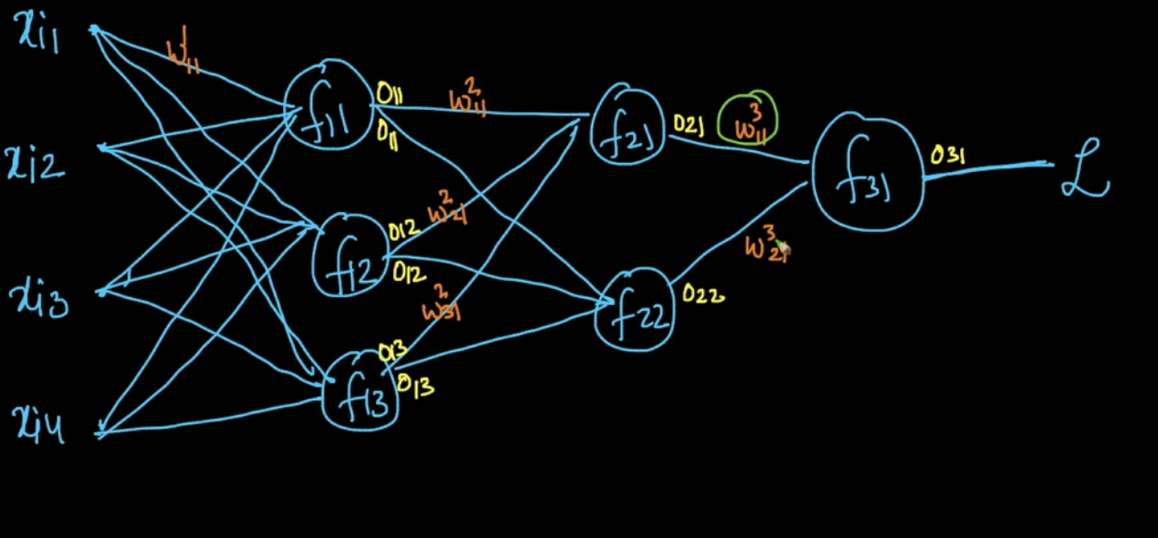

**Using Chain Rule during gradient Calculation:**

**Derivative of L w.r.t to w311 :**

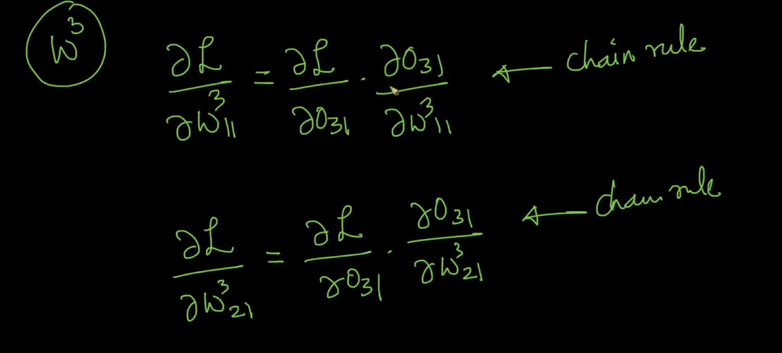

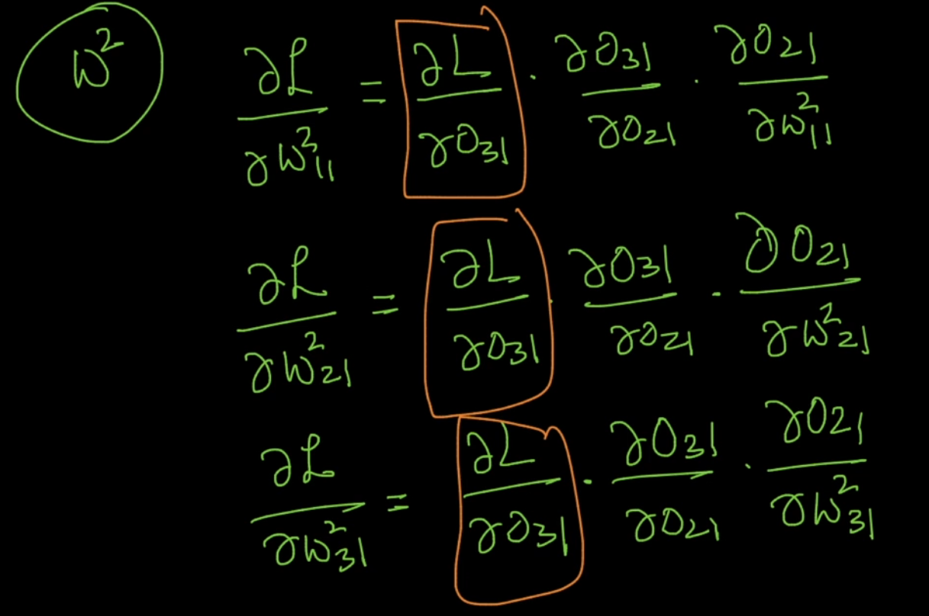

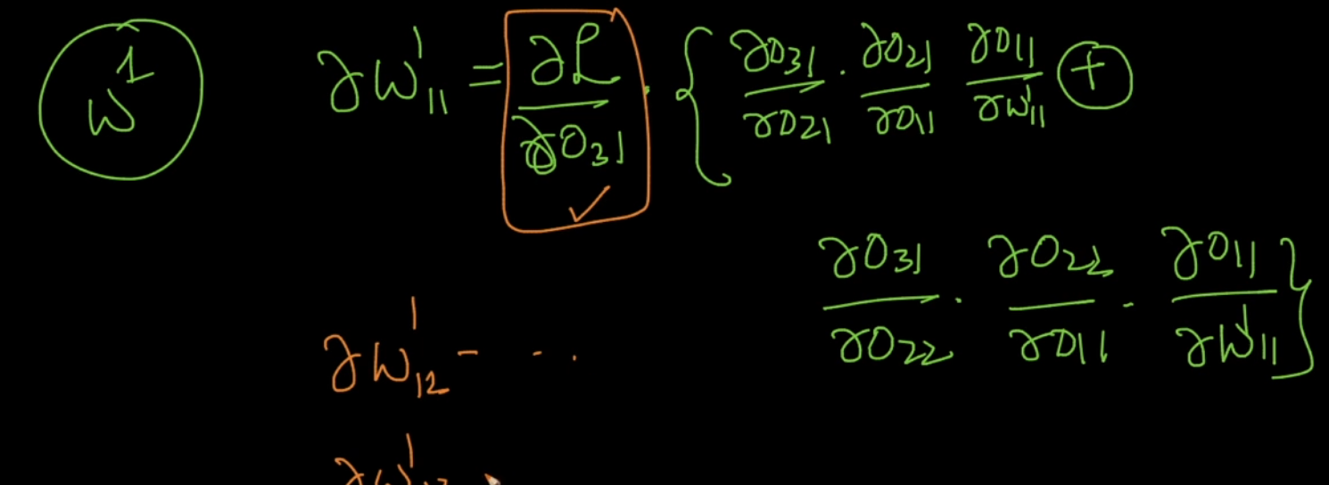

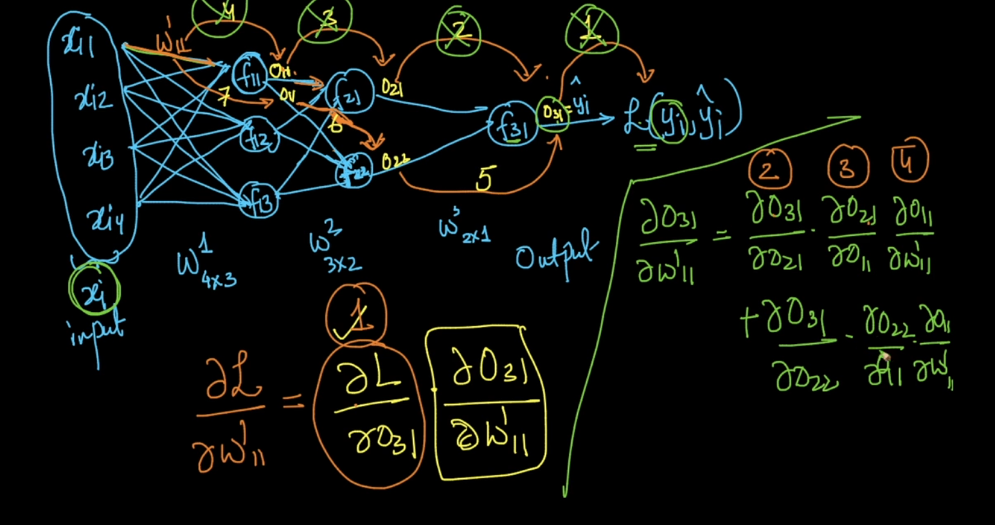

**Creating A Keras Deep Learning Model:**

**Model Building Steps:**

1. Specify the architecture.
   1. Import numpy as np
   2. From keras.layers import Dense
   3. From keras.models import Sequential
   4. Predictors=np.loadtxt(‘predictions.csv’,delimiter=’,’)
   5. n_cols=Predictors.shape[1]
   6. model=Sequentia()#There are two ways to define a model Sequential() is one such process which is easy.
   7. model.add(Dense(100,activation=’relu’,input_shape=(n_cols,)))#Dense layers means all the neurons in one layers are connected to another layer.  
      Input_shape=(n_cols,) means it can have any number of rows
   8. model.add(Dense(100,activation=’relu’))
   9. model.add(Dense(1))#output has only one node
2. Compile the model.
   1. **Specify the optimizer**(this controls the learning rate)
      1. Many options and mathematically complex
      2. Adam is usually good
   2. **Loss Function:** Mean squared error common for Regression

**Model.compile(optimizer=’Adam’, loss=’mean-squared-error’)**

1. Fit the model which involves forward and back propogation
   1. Apply back prop and gradient descent with your data to update the weights.
   2. Scaling data before fitting eases optimization

Model.fit(predictors, target)

1. Use the model for prediction.

**Classification Loss function : Categorical cross entropy**

**Softmax Activation Function :** It ensure that the predictions sum to 1 to make interpretation easy.

**Code for classification using Keras:**

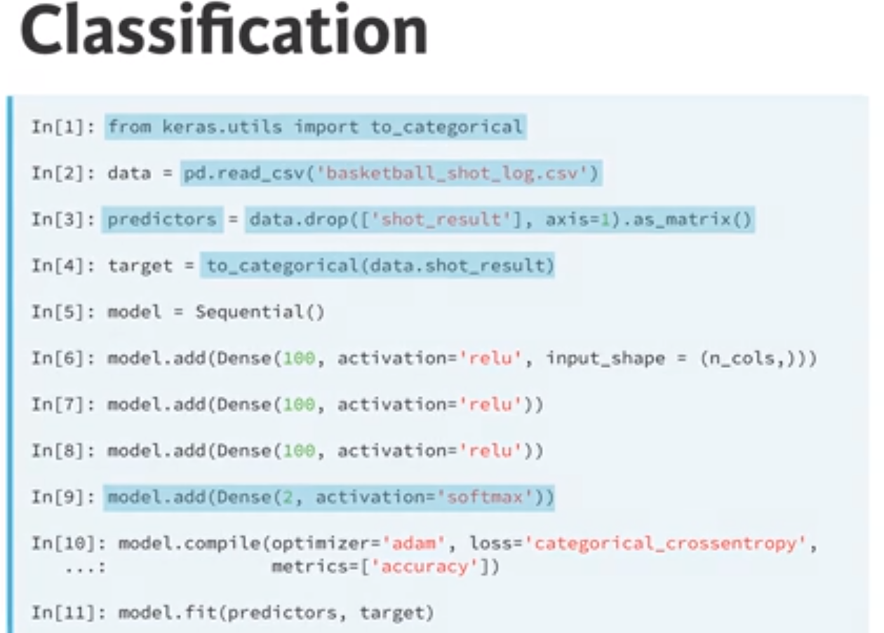

**The dying neural problem:**

Once the neuron gets a negative value , it will never turn back to positive value and it will no longer contribute to learning.

Instead of using a string value inside optimizer like ‘sgd’, the function SGD() can be used when we want to have a different lr value than the provided default value in SGD()

For eg: model.compile(optimizer=SGD(lr=0.05),loss=’categorical_crossentropy’,metrics=[‘accuracy’])

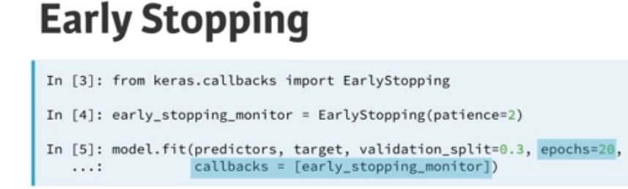

It is a neural network technique which can be used to stop NN training in case of no improvement in validation loss. Patience=3 means wait for atleast 3 epochs ad stop training if there is no further improvement. The model may increase its performance during training after 2 epochs but 3 should be a good value if model doesn’t learn anything for 3 epochs its likely that it will not improve further.

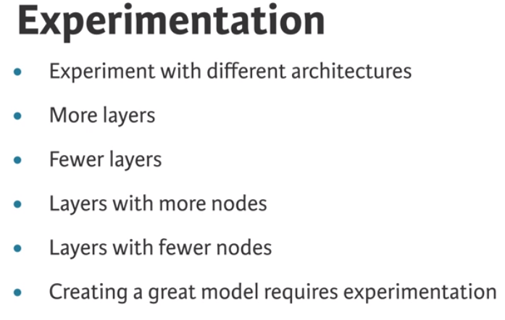

**Model Capacity or Network Capacity:**

Model capacity or network capacity is largely related to Overfitting and underfitting

Overfitting: It is the process in which model fits the odds/happenstances in the training data which will never repeat in the validation data or test set. Due to which accuracy will be high for training set and will be low for test/validation set.

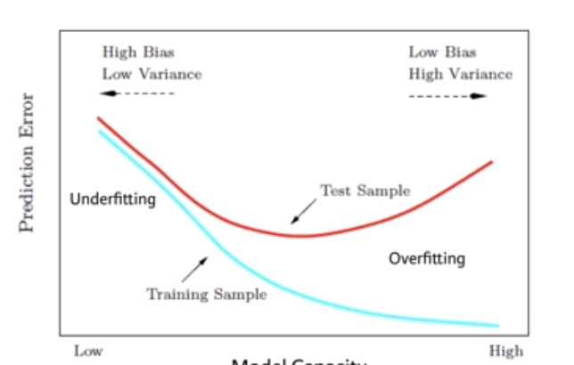

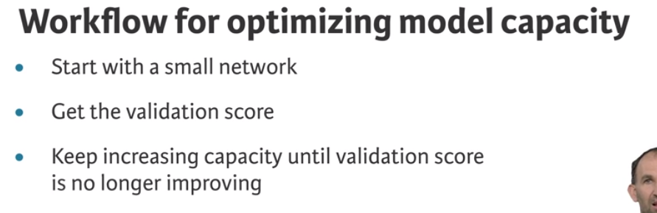

Whenever we are using Convolution Neural Network tasks it’s better to have Relu function because , as we know convolution performs linear operation hence by using relu we are introducing non linearity.

Deep neural networks are effective when we have the perfect settings.

The advantage of using Keras is that using Keras.json the backend can be changed to either of tensorflow, keras without any change in code.

Each layer in Keras is a callable object.

To add Drop out layer: model.add(Dropout(0.2))

There is a tool with Keras+hyperopt which can be used for Neural network hyper parameter fine tuning.

Deep Learning in TensorFlow(LYNDA)

**Session:** session is an object in tensorflow that runs operations on the computational graph and tracks the status of each node in the graph.

For tensorboard visualization:

Need to create log of the model training using tf.summary.writer. refer to DeepLearning->LYNDA->04->model_logging.py for implementation

Post capturing the logs open pycharm terminal or cmd and type:

Tensorboard --logdir=directory of logs without quotes

**PYTORCH**

The main advantages of pytorch are:

We can use set_trace() to perform debugging in pytorch whereas it is not possible in tensorflow we have only enable_eager_execution().

Tensors in pytorch are similar to numpy arrays, where direct operations can be performed by using pytorch tensors for Eg: np.eye(3) creates an indentity array. In pytorch similar operation can be done by using torch.eye(3)

Flexibility to move computations to gpu if required. If we want the computation to happen on GPU we can call .to(device) on the object the computation will happen on GPU(assign cuda object to device) for eg: model.to(device)(Refer to below image)

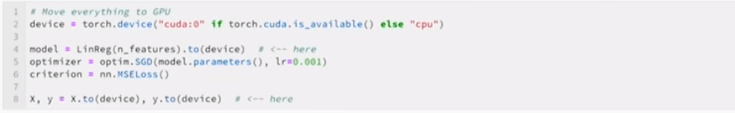

Pytorch is very flexible it can be used to perform different experimentations during training.

**Why do we need tensors why cant we use numpy arrays for Deep Learning ?**

Tensors are capable of tracking the changes within itself which are used during backpropogation or gradient calculation.

**Activation Functions:**

**Sigmoid Activation Function:**Requirements of Activation functions: Activation functions should be differentiable.

Activation functions are used to introduce non linearity among neurons

**Ronny.net(blog post on sigmoid activation)**

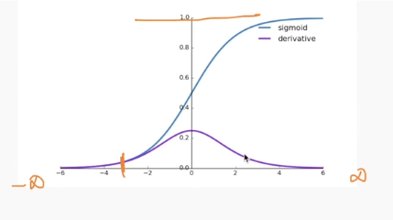

The derivative of sigmoid lies between 0 and 1.

**Tanh Function:Refer to same blogpost from ronny for tanh also .**

It is similar to sigmoid but some changes.

If the hidden layer use tanh as an activation function then the mean of activation function output will be around 0 which will make learning easier for the next layer but it will not be around 0 for sigmoid.

**Relu Activation Function:**

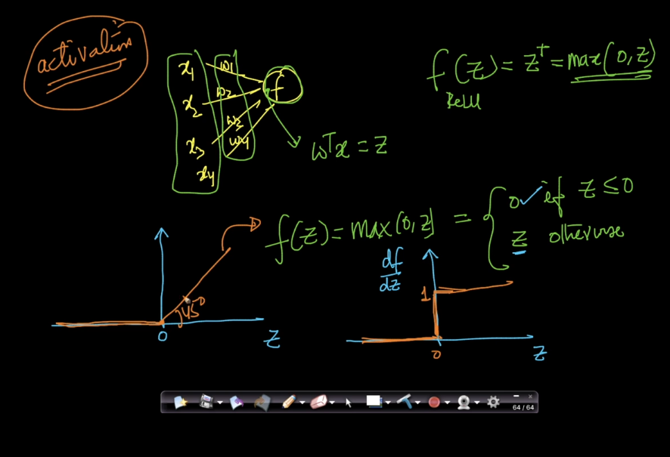

The derivative of relu function is either 0 or 1. Due to which we will not have either of vanishing or exploding gradients but since we have derivative of 0 we could have problem of dead activations.

The derivative of relu is easier to compute when compared to sigmoid and tanh.

When our Z(w*x+b) is negative, then our derivative of relu is zero. If derivative is zero then the neuron containing negative z will be a dead neuron.

We can use various initialization techniques to avoid z becoming negative.

Other versions of Relu called Noisy relu, leakyrelu(range of derivative is (small value between 0-1,1). If there are more dead neurons try leaky relu.

The main advantage of Relu over sigmoid and tanh is given a hypothesis space of parameter, less number of weights have gradient or slope equal to zero which will make learning faster because gradient is non zero.Whereas in case of sigmoid and tanh more weights will have gradients or slope as zero(refer to diagram of tanh/sigmoid where the weights having values from 0.8 to 1 have gradients or slope equal to zero)

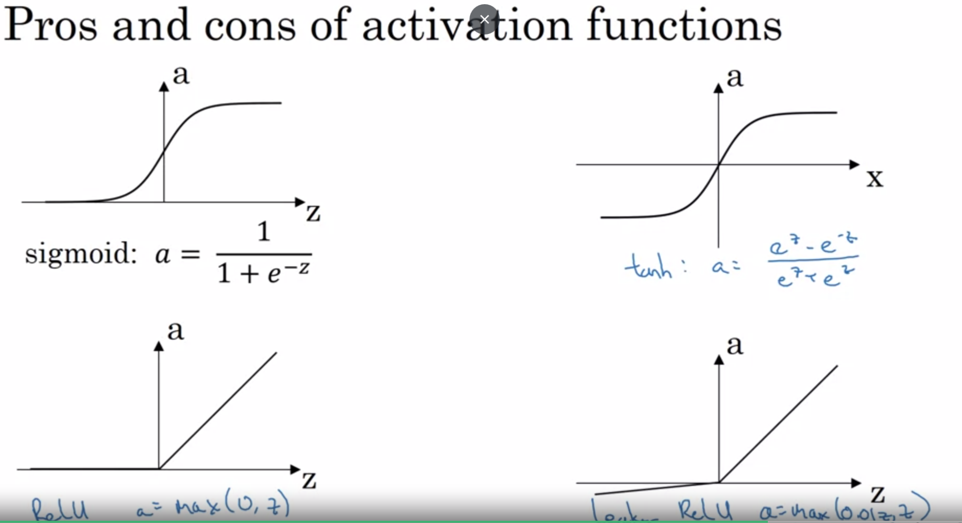

Why do you need non-linear activation functions?

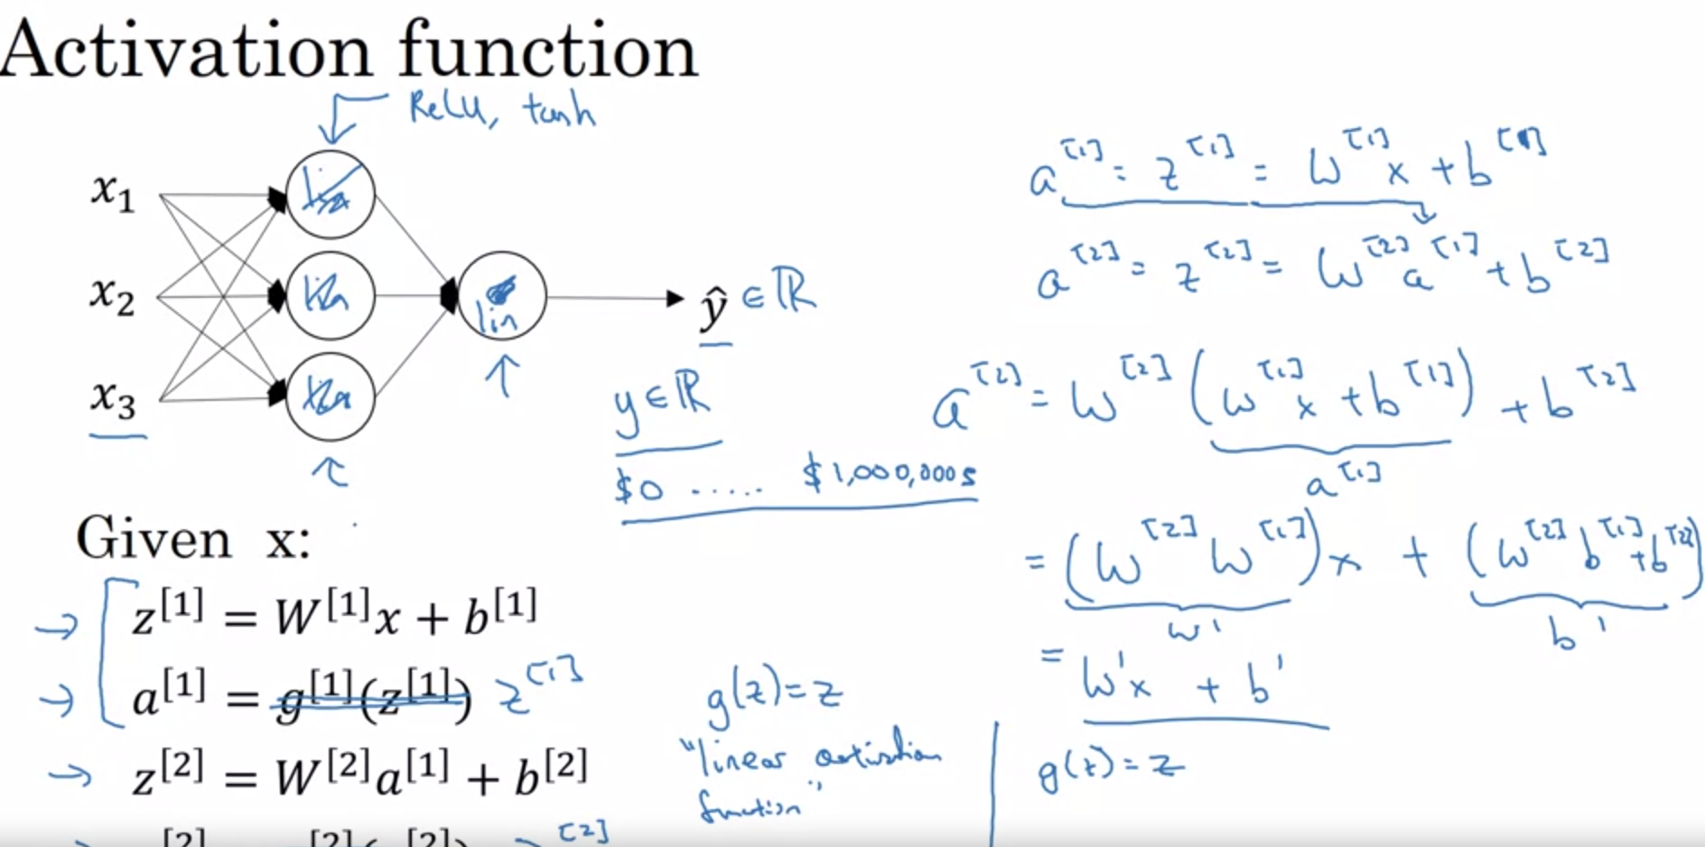

**Vanishing Gradient Problem:**

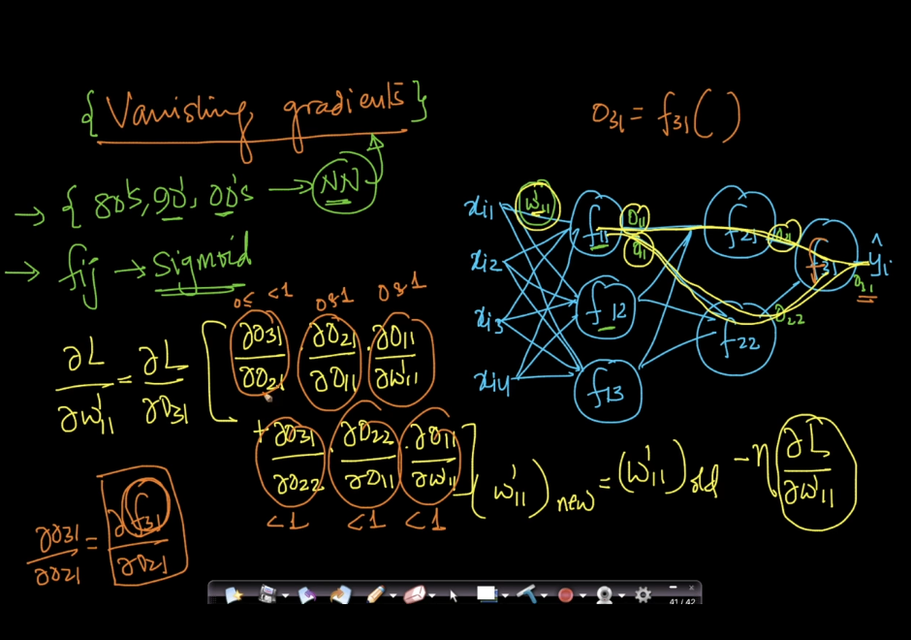

As we see in above diagram, When we use chain rule back prop the gradient of cost function w.r.t first layer weights is multiplication of various values which are in range(0,1) due to which the final gradient of cost w.r.t to initial layer weight is very less . Due to which there will not be much change in our weight value(below image).

If there is no change in our weights there will not be much learning in the initial layers.

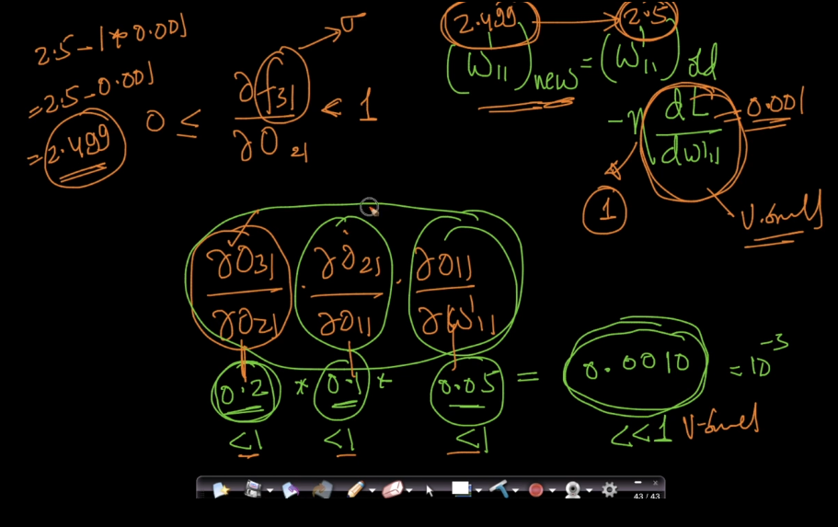

This problem is more evident with Sigmoid/Tanh activation functions as the range of derivatives of sigmoid and tanh is between (0 and 1). SO to overcome this problem we use Relu or Leaky Rule or perform Gradient Clipping.

Similar to vanishing gradient problem we have exploding gradient problem which is more evident in RNN.

**Weight Initializations:**

* What if we have all our weights to a 0 value to start with?
* In such learning will be 0
* All gradient updates will have same value.

**Properties of ideal weights?**

* Weights should be small(not too small)
* Not all weights should be zero.
* The weights should have good variance. More variability they have better the weights.
* Ideal weight distribution: Normal distribution with mean 0 and small variance.(This contains some positive and negative and it works well)

**Better Initialization Strategies:**

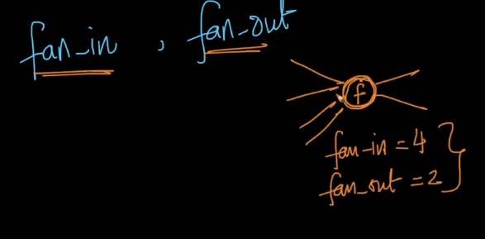

These initialization techniques depends on fan-in and fan out.

**Uniform-initialization(works well for sigmoid):**

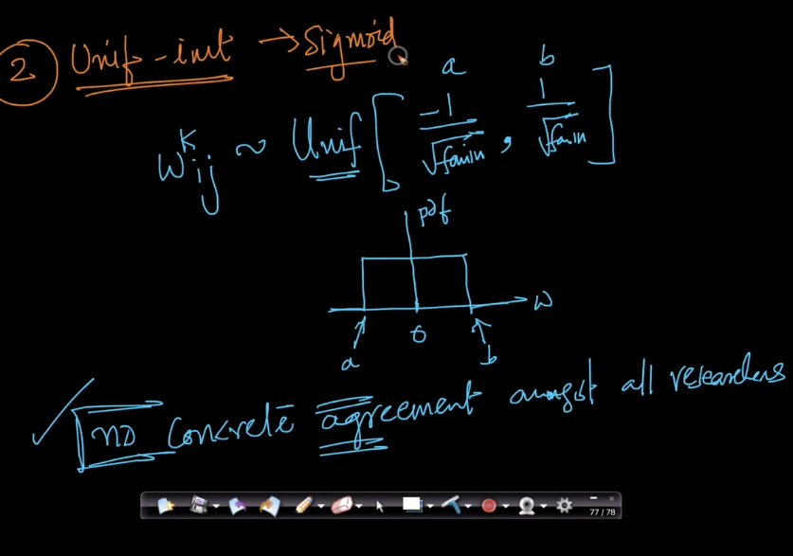

**Xavier or Glorot Initialization(works good for sigmoid,tanh):**

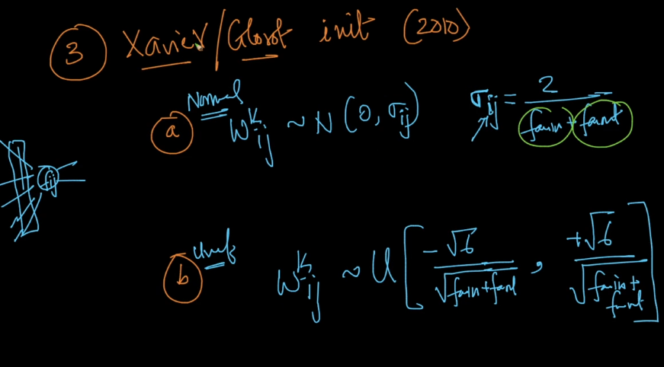

**He initialization(Works good for Relu and Leaky Relu):**

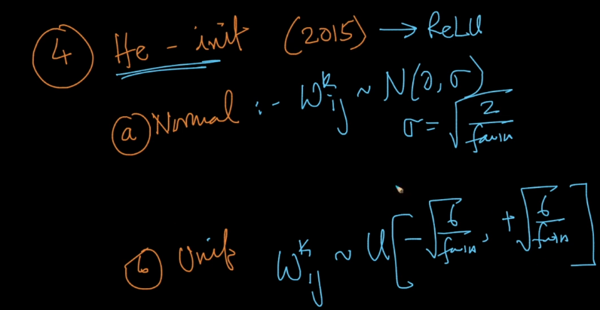

**Batch Normalization:**

This process is much useful in case of Deep Networks.

Assume a Minibatch SGD setup , In case of deep neural networks a small change in input data point will cause a large change in later layers.(as shown in below image a input of 1.01 when it reaches layers 5 it increases by 37%)  
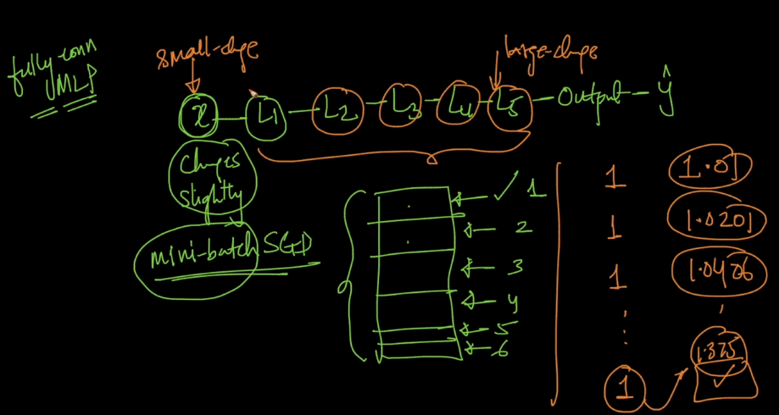

Even thought the input data is normalized , but we can still see that a small change in input data batches we can see large change in input when it reaches layer5 or deep nn layers. Hence for each batch the values at layer 5 or deep layers change significantly. This problem is called internal covariance shift.

This problem can be solved by using a batch normalization layer in deep layers.

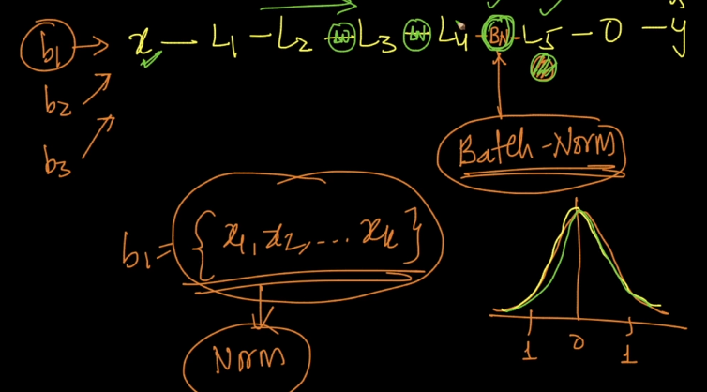  
This problem can be solved by using Batch normalization layer as shown above.

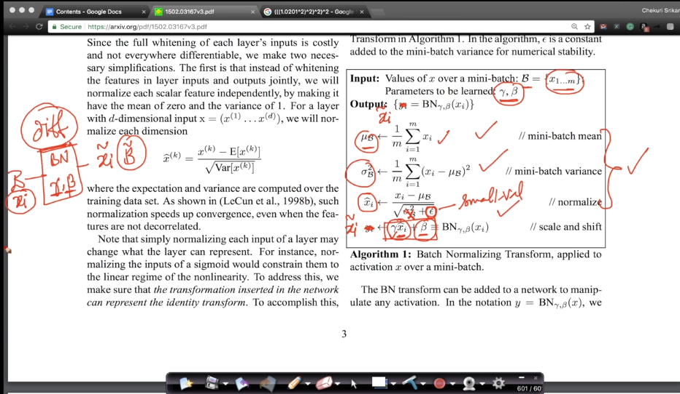

Batch normalization hyperparameters gamma and beta are learned during backprop because they can be differentiable.

**Advanatages:**

Faster convergence.

We can afford to have larger learning rate.

It also acts as weak regulrizer include drop outs as well

Avoid internal covariate shift.

**Optimization process**

Slope is zero at maxima and minima.

**Mathisfun.com/maxima-minima**

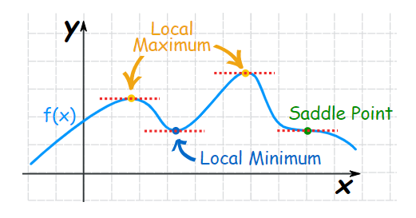

* If gradient is zero that means its either of Local maximum, local minimum, saddle point.
* There are chances that Minibatch-SGD could get stuck at saddle point.
* For convex functions localminima=global minima
* There is mathematical proof that logistic regression, linear regression, SVM(al forms) the loss is convex function for these cases.
* For deep learning loss is non convex and there may be many local minima’s and based on initializations we could land up at different minimas.
* We can understand 3d optimization plots with contour plots .
* Contour plots are circles such that points inside the contour have same loss value

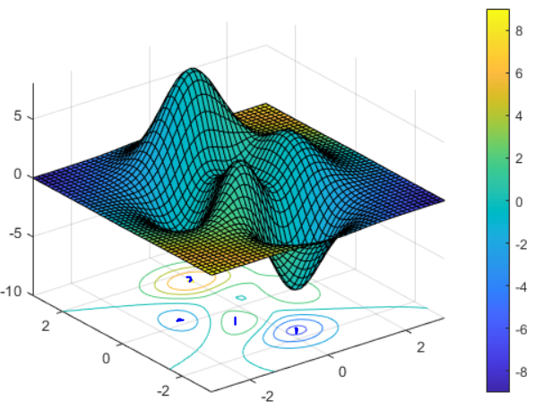

In the above plot each dot represents a local minimum and each each contour plot signifies points with same loss function.

**SGD with Momentum**

The gradients calculated using SGD are noisy because we take a batch of data points for sgd and those batch may have noisy data. Hence to avoid noisy updates we use SGD with momentum.

While updating each weight during backprop , the previous iterations gradients are also weighted and used for current weight updation.

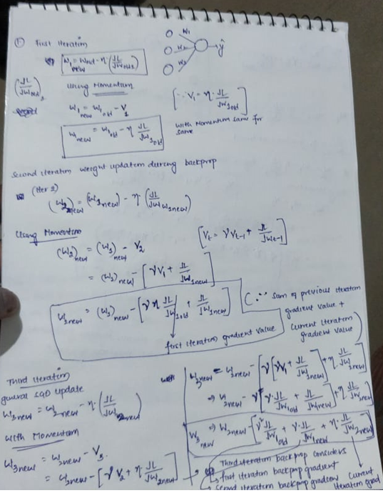

The entire process will help in denoising the gradients and speed up the convergence.

More information in blog by Sebastian Ruder.

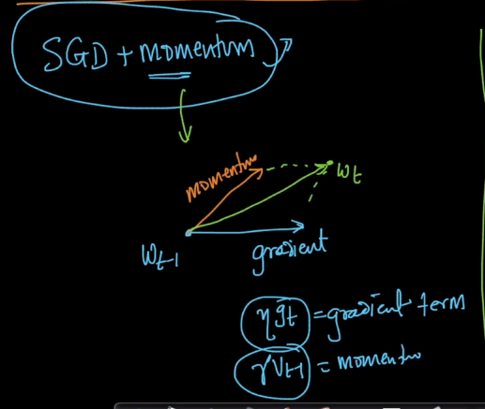

**Nestrov Accelerated Gradient (NAG)**

In SGD with momentum we add our momentum with our gradient and then move in the resulting direction , But in this method we first move in direction of momentum and then the gradient is calculated with respect to new weight value.

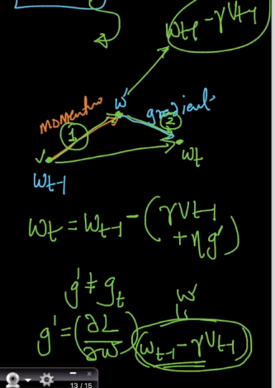

**Adagrad(Adaptive Gradients)**

The main idea behind adagrad is to have different learning rates for different iterations . Because when data contains sparse features having constant learning rate will not help much .

**MaxPooling:**

Maxpooling works in such a way that given an image it will look for the higher value in that position . This makes it very less sensitive to position. This is very helpful when we have objects positioned left or right or anywhere , maxpool helps us identify them.

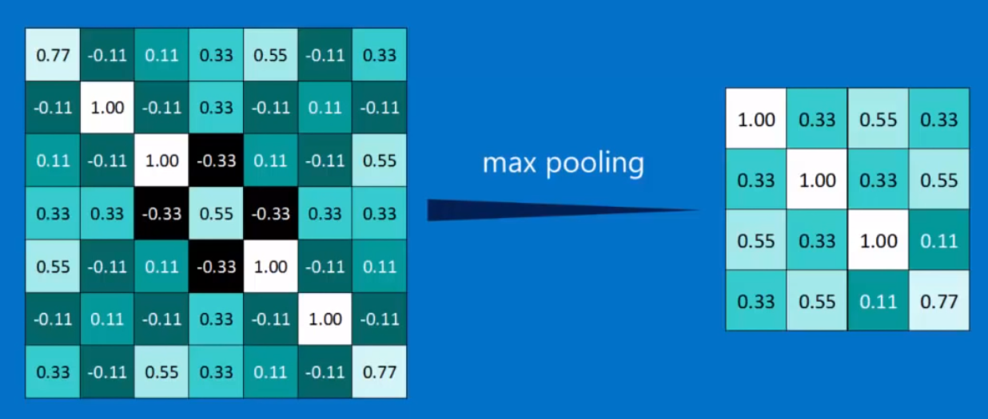

Maxpooling tries to downsample the image , by keeping the pattern in the image undisturbed. For eg: higher pixels are available in the diagonal line of the image , post max pooling the higher pixels are still available in the diagonal line.

The below image shows that max pool down samples the images while retaining the pattern in the image.

